1. **Create a VPC (Virtual Private Cloud) –**

**Name: Govardhan-vpc**

AWS uses software-defined networks to offer a small network that is secure from others called a Virtual Private Cloud (VPC).

1. Find the VPC Service using the search at the top
2. Start the **VPC Wizard**. (**This is an important step** because the VPC Wizard sets up other necessary components of the VPC, such as the Internet Gateway. Please double check that you used the VPC Wizard and not just the “Create VPC” option.)
3. On the default tab, “VPC with a Single Public Subnet”, click Select. (The subnet is a subset of the whole AWS network that is available.)
4. On “Step 2”, you’ll need to change a few bits of information:
   1. **IPv4 CIDR Block:** 10.0.0.0/26
   2. **VPC Name:** *my-name*-vpc
   3. **Public Subnet’s IPv4 CIDR:** 10.0.0.0/28
   4. Everything else can be left as the default
5. The click “Create VPC”

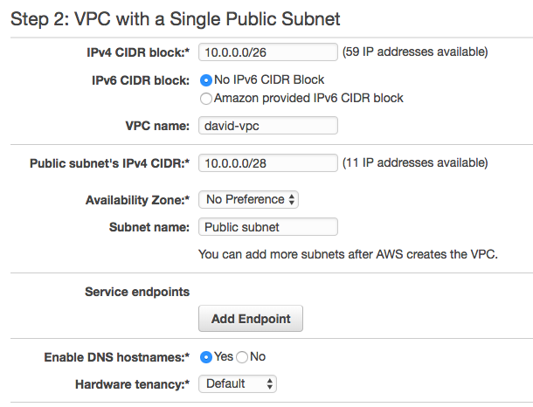

*Note for the curious*: If you're unfamiliar with CIDR notation, the number after the '/' indicates the size of the network. For example, the 28 in the subnet specifies that the first 28 bits of the 32-bit IP address are the same, meaning the last 4 bits are variable. This means the subnet is made of all the IP addresses between 10.0.0.0 and 10.0.0.15. AWS reserves 5 of the IPs for networking (e.g. a router, DNS), leaving your subnet with 11 available IP addresses for instances.

You've now configured a secure VPC and subnet - use them whenever you spin up nodes. Let’s setup budges next to you can track your expenses in AWS.

1. **Create Security Groups:**

Created 3 security groups initially:

1. One to access ssh from home IP address
2. One to allow downloads
3. One to allow internal communication between machines with this security group

Follow this video: <https://www.youtube.com/watch?v=3taULsvuZUM&feature=youtu.be>

For Tuesday:

Create ec2 instances, Install Pulsar

1. **Create EC2 instances:**

Created 3 EC2 instances – t2.small for Zookeepers and then SSH into the instance with the pem keypair file

Zookeepers:

10-0-0-4 – server 1

10-0-0-9 – server 2

10-0-0-7 – server 3

ssh -i ~*location of the pem file* ubuntu@*Ec2instancePublicDNS*

Create 3 EC2 instances – m4.large for PulsarBrokersand Bookie and then SSH again

Pulsar Brokers:

10-0-0-10

10-0-0-14

10-0-0-08

Install JAVA 8 on all the machines.

Sudo apt update

Sudo apt install openjdk-8-jdk

1. Follow <https://pulsar.apache.org/docs/en/deploy-bare-metal/> for installation of pulsar.

* Install the Pulsar binary package
* After that install tiered storage offloaders in all the broker systems
* Have to deploy a zookeeper cluster

Use :

echo server.1=ec2-34-221-137-48.us-west-2.compute.amazonaws.com:2888:3888 >> ./conf/zookeeper.conf

to add server to talk to. Make sure these are your zookeeper instance’s IP

nano conf/zookeeper.conf // lets you view the file

<https://livebook.manning.com/book/pulsar-in-action/chapter-1/v-3/>

<https://dzone.com/articles/an-introduction-to-stream-processing-with-pulsar-f>

<https://dzone.com/articles/a-developers-introduction-to-the-pulsar-streaming>

<https://www.xenonstack.com/blog/apache-pulsar/>

<https://www.confluent.io/kafka-vs-pulsar/>

10-0-0-10 – client conf

10.0.0.12 – Producer

Install sudo apt python3-pip

Netstat -tulnup | grep portnumber